Data Mining Midterm Project
First Name: Harini Reddy
Last Name: Gade
NJIT UCID: hg294
E-Mail ID: hg294@njit.edu

CODE:
I took 30 items from Target that we usually find and implemented this code

import itertools
import os
import random
import time
import pandas as pd
from rich import print
from rich.table import Table
item_list = ['Beverages', 'Baby Monitors', 'Clothes', 'Electronics', 'Home Decor', 'Vegetables', 'Pantry', 'Dog Food', 'Furniture', 'Coffee', 'Cups', 'Flowers', 'Roblox', 'Pizza Rolls', 'Tennis Racket', 'Playstation', 'Okra', 'Laptop', 'Croutons', 'Cereals', 'Pepperoni', 'Sleeping Bag', 'Brussel Sprouts', 'Cardigans', 'Apples', 'Go Pro', 'Mangoes', 'Broccoli', 'Lamps', 'Pillows']

DEFAULT_MIN_SUPPORT = 0.5

class Transaction:
def __init__(self, items):
self.items = items
self.size = len(items)

def __str__(self):
output = ""
for item in self.items:
output += item + " "
return output

def __repr__(self):
output = ""
for item in self.items:
output += item + ", "
return output

def contains(self, item):
return item in self.items

def contains_all(self, items):
for item in items:
if not self.contains(item):
return False
return True

class Dataset:
def __init__(self):
self.transactions = []

def __str__(self):
output = ""
for transaction in self.transactions:
output += str(transaction) + "\n"
return output

def __repr__(self):
output = ""
for index, transaction in enumerate(self.transactions):
output += f"{index+1}: {transaction.__repr__()}\n"
return output

def add_transaction(self, transaction):
self.transactions.append(transaction)

def is_empty(self):
return len(self.transactions) == 0

def get_size(self):
return len(self.transactions)

def save(self, filename):
with open(filename, "w") as f:
for transaction in self.transactions:
f.write(str(transaction) + "\n")

def get_support(self, item):
count = 0
for transaction in self.transactions:
if transaction.contains(item):
count += 1
return count

def get_support_for_items(self, items):
count = 0
for transaction in self.transactions:
if transaction.contains_all(items):
count += 1
return count

def get_confidence(self, items, item):
return self.get_support_for_items(items + [item]) / self.get_support_for_items(items)

def get_itemset(self):
itemset = []
for transaction in self.transactions:
for item in transaction.items:
if item not in itemset:
itemset.append(item)
return itemset
class DatasetFactory:
@staticmethod
def create_dataset(dataset_type, **kwargs):

if dataset_type == "random":
return DatasetFactory.create_random_dataset(**kwargs)
elif dataset_type == "file":
return DatasetFactory.create_dataset_from_file(**kwargs)
elif dataset_type == "user":
return DatasetFactory.create_dataset_from_user_input()
else:
raise Exception("Invalid dataset type")

@staticmethod
def create_random_dataset(num_transactions=20, max_items_per_transaction=5):

dataset = Dataset()
for i in range(num_transactions):
num_items = random.randint(1, max_items_per_transaction)
items = random.sample(item_list, num_items)
dataset.add_transaction(Transaction(items))
return dataset

@staticmethod
def create_dataset_from_file(filename):
dataset = Dataset()
with open(filename, "r") as f:
for line in f:
items = line.split()
dataset.add_transaction(Transaction(items))
return dataset

@staticmethod
def create_dataset_from_user_input():
# Used for testing
dataset = Dataset()
while True:
print("Enter a comma that seperates the list of items in the transaction. Enter 'end' to finish.")
line = input()
if line == "end":
break
items = line.strip().split(",")
dataset.add_transaction(Transaction(items))
return dataset

def brute_force(dataset, min_support):

frequent_itemsets = []

itemset = dataset.get_itemset()

for i in range(1, len(itemset) + 1):
num_freq_itemsets_i = 0
for subset in itertools.combinations(itemset, i):
support = dataset.get_support_for_items(subset)
if support >= min_support:
subset = list(subset)
subset.sort()
frequent_itemsets.append(subset)
num_freq_itemsets_i += 1
if num_freq_itemsets_i == 0:
break

frequent_itemsets.sort(key=len)

return frequent_itemsets

def get_candidates(frequent_k_itemsets, k):

candidates = []
for i in range(len(frequent_k_itemsets[1])):
for j in range(len(frequent_k_itemsets[k-1])):
itemset = frequent_k_itemsets[1][i] + frequent_k_itemsets[k-1][j]
itemset.sort()
if len(set(itemset)) == k:
if itemset not in candidates:
candidates.append(itemset)

return candidates

def apriori(dataset, min_support):

itemset = dataset.get_itemset()

frequent_itemsets = []

frequent_1_itemsets = []
for item in itemset:
support = dataset.get_support(item)
if support >= min_support:
frequent_1_itemsets.append([item])

frequent_itemsets += frequent_1_itemsets

frequent_k_itemsets = {
1: frequent_1_itemsets
}
for k in range(2, len(itemset) + 1):
candidates = get_candidates(frequent_k_itemsets, k)

frequent_i_itemsets = []

for candidate in candidates:
support = dataset.get_support_for_items(candidate)
if support >= min_support:
frequent_i_itemsets.append(candidate)

frequent_itemsets += frequent_i_itemsets
frequent_k_itemsets[k] = frequent_i_itemsets

if len(frequent_i_itemsets) == 0:
break

frequent_itemsets.sort(key=lambda x: len(x))

return frequent_itemsets

def generate_rules(dataset, frequent_itemsets: list, c=0.5):

rules = []
for itemset, support in frequent_itemsets:
k = len(itemset)
for i in range(1, k):
subsets = list(itertools.combinations(set(itemset), i))
for a in subsets:
support_a = dataset.get_support_for_items(a)
confidence = support / support_a

if confidence >= c:
rules.append((set(a), set(itemset).difference(set(a)), confidence))

return rules

def output_rules(file_path, rules):
df = pd.DataFrame([[create_str_rule(rule[0], rule[1]), rule[2]] for rule in rules],
columns=["rule", "confidence"])
df.to_csv(file_path, sep="\t")

def create_str_rule(left, right):
return ', '.join(left) + " -> " + ', '.join(right)

def main():
print("Would you like to use the existing dataset? (y/n)")
if input() == "y":
try:
for i in range(1, 6):
with open("data/datasets/dataset{}.txt".format(i), "r") as f:
pass
except FileNotFoundError:
print("There are no such Datasets")
return
datasets = []
for i in range(1, 6):
datasets.append(DatasetFactory.create_dataset_from_file("data/datasets/dataset{}.txt".format(i)))

else:
print("Would you like to save the Datasets? (y/n)")
save_datasets = input() == "y"
datasets = []
for i in range(1, 6):
datasets.append(DatasetFactory.create_random_dataset())
if save_datasets:
datasets[i-1].save("data/datasets/dataset{}.txt".format(i))
print("Dataset {} saved".format(i))
min_support = float(input("Enter min support : "))
min_confidence = float(input("Enter min confidence : "))

for i in range(5):
print("Dataset " + str(i) + ":")
print("-------------------------------------------")
print(datasets[i].__repr__())

answers_brute = []
times_brute = []
print("Brute force algorithm:")
for i in range(5):
start_time = time.time()
answers_brute.append(brute_force(datasets[i], min_support))
end_time = time.time()
times_brute.append(end_time - start_time)
answers_apriori = []
times_apriori = []
print("Apriori algorithm:")
for i in range(5):
start_time = time.time()
answers_apriori.append(apriori(datasets[i], min_support))
end_time = time.time()
times_apriori.append(end_time - start_time)
print("Comparision of two algorithms:")
for i in range(5):
print(f"Dataset {i}:")
print(f"Brute force algorithm:\n{answers_brute[i]}\n")
print(f"Apriori algorithm:\n{answers_apriori[i]}\n")

for i in range(5):
if answers_brute[i] != answers_apriori[i]:
print(f"Dataset {i}: Results vary in two Algorithms")
break
else:
print("Same results were shown for both the Algorithms")

frequent_itemsets = {
0: [],
1: [],
2: [],
3: [],
4: []
}
for i in range(5):
print(f"Dataset {i}:")
for itemset in answers_brute[i]:
if len(itemset) > 1:
support = datasets[i].get_support_for_items(itemset)
frequent_itemsets[i].append((itemset, support))
print(f"Itemset: {itemset}, Support: {support}")

for i in range(5):
print(f"Dataset {i}:")
rules = generate_rules(datasets[i], frequent_itemsets[i], min_confidence)
print(f"Rules: {rules}")
output_rules(f"data/rules/rules{i}.txt", rules)
print("Comparision of the execution times of the two algorithms:")
table = Table(show_header=True, header_style="bold magenta")
table.add_column("Dataset", justify="center")
table.add_column("Brute force algorithm", justify="center")
table.add_column("Apriori algorithm", justify="center")
for i in range(5):
table.add_row("Dataset " + str(i+1), f"{times_brute[i]: .3f}", f"{times_apriori[i]: .3f}")
print(table)

if __name__ == "__main__":
main()

DATASETS:
I took 5 datasets as told.
DATASET1:
Cereals Croutons Laptop
Beverages Pillows Playstation Tennis Racket Laptop
Pantry Go Pro
Flowers
Tennis Racket Broccoli
Okra Coffee Roblox Mangoes Pepperoni
Electronics Tennis Racket Sleeping Bag
Electronics Pepperoni Apples
Okra Cardigans Cereals Sleeping Bag Clothes
Vegetables
Roblox
Baby Monitors Electronics Go Pro Apples Vegetables
Mangoes Baby Monitors Pantry
Okra Pizza Rolls Sleeping Bag
Tennis Racket Electronics Mangoes
Furniture
Playstation
Flowers Go Pro Baby Monitors
Clothes Flowers Cereals Sleeping Bag
Pepperoni
DATASET2:
Furniture
Pizza Rolls Beverages Vegetables Mangoes
Roblox Brussel Sprouts Croutons
Cups
Broccoli Home Decor
Pillows Apples Cups Okra
Flowers Mangoes Roblox Pantry
Furniture Flowers Dog Food
Brussel Sprouts Cardigans
Cereals Mangoes Baby Monitors Sleeping Bag
Pizza Rolls
Electronics Dog Food Vegetables
Lamps Coffee Go Pro
Cups
Tennis Racket
Roblox Lamps Apples
Cups
Clothes Croutons Cups Go Pro Pizza Rolls
Cups
Dog Food Furniture
DATASET3:
Electronics Sleeping Bag Baby Monitors Cups
Cereals
Laptop Vegetables
Home Decor Pillows Baby Monitors
Pantry Croutons Playstation
Pepperoni Broccoli Baby Monitors Home Decor Dog Food
Mangoes Pantry Pillows Cardigans
Electronics Cereals Baby Monitors Pantry Go Pro
Go Pro Vegetables Flowers Brussel Sprouts Okra
Playstation
Home Decor
Pillows Laptop Pantry Cups
Brussel Sprouts Apples
Home Decor Playstation Sleeping Bag Cardigans
Cardigans Pantry Coffee
Mangoes
Dog Food
Home Decor Brussel Sprouts Apples Pantry Cardigans
Dog Food Pantry
Go Pro Electronics

DATASET4:
Sleeping Bag Cups Vegetables Okra
Brussel Sprouts Beverages
Laptop Pepperoni Cereals
Cardigans Clothes Furniture
Sleeping Bag Laptop Playstation Cereals Okra
Laptop Mangoes
Dog Food
Coffee Broccoli
Okra Broccoli Furniture Tennis Racket Clothes
Sleeping Bag Pantry Beverages Laptop Lamps
Laptop Mangoes
Cereals
Playstation
Cups Vegetables Go Pro
Furniture Go Pro
Brussel Sprouts Sleeping Bag Beverages Apples
Vegetables
Mangoes
Furniture
Furniture Mangoes Vegetables Cardigans

DATASET5:
Pizza Rolls Beverages
Go Pro Apples Sleeping Bag
Apples Cereals
Coffee Flowers Tennis Racket Dog Food Home Decor
Pizza Rolls Baby Monitors Home Decor Go Pro
Okra Pepperoni Roblox Cardigans
Cereals Home Decor Laptop Croutons
Tennis Racket Pillows
Croutons Dog Food Pepperoni Pillows Apples
Cereals Baby Monitors Cardigans Furniture Laptop
Coffee
Beverages Playstation
Mangoes Apples Roblox
Pillows Cereals Sleeping Bag Home Decor Lamps
Broccoli Playstation Home Decor
Mangoes Lamps Croutons Clothes Sleeping Bag
Brussel Sprouts Okra Croutons Go Pro
Sleeping Bag Lamps Vegetables Cardigans Croutons
Cereals Playstation Home Decor Okra
Go Pro Sleeping Bag Cereals

RULES0:
rule confidence
0 Cereals -> Sleeping Bag 0.6666666666666666
1 Sleeping Bag -> Cereals 0.5
2 Cereals -> Clothes 0.6666666666666666
3 Clothes -> Cereals 1.0
4 Electronics -> Tennis Racket 0.5
5 Tennis Racket -> Electronics 0.5
6 Go Pro -> Baby Monitors 0.6666666666666666
7 Baby Monitors -> Go Pro 0.6666666666666666
8 Okra -> Sleeping Bag 0.6666666666666666
9 Sleeping Bag -> Okra 0.5
10 Apples -> Electronics 1.0
11 Electronics -> Apples 0.5
12 Sleeping Bag -> Clothes 0.5
13 Clothes -> Sleeping Bag 1.0
14 Cereals -> Sleeping Bag, Clothes 0.6666666666666666
15 Sleeping Bag -> Cereals, Clothes 0.5
16 Clothes -> Cereals, Sleeping Bag 1.0
17 Cereals, Sleeping Bag -> Clothes 1.0
18 Cereals, Clothes -> Sleeping Bag 1.0
19 Sleeping Bag, Clothes -> Cereals 1.0
RULES1:
rule confidence
0 Furniture -> Dog Food 0.6666666666666666
1 Dog Food -> Furniture 0.6666666666666666
RULES2:
rule confidence
0 Electronics -> Baby Monitors 0.6666666666666666
1 Baby Monitors -> Electronics 0.5
2 Electronics -> Go Pro 0.6666666666666666
3 Go Pro -> Electronics 0.6666666666666666
4 Baby Monitors -> Home Decor 0.5
5 Cardigans -> Home Decor 0.5
6 Pillows -> Pantry 0.6666666666666666
7 Cardigans -> Pantry 0.75
8 Apples -> Brussel Sprouts 1.0
9 Brussel Sprouts -> Apples 0.6666666666666666
RULES3:
rule confidence
0 Okra -> Sleeping Bag 0.6666666666666666
1 Sleeping Bag -> Okra 0.5
2 Sleeping Bag -> Beverages 0.5
3 Beverages -> Sleeping Bag 0.6666666666666666
4 Sleeping Bag -> Laptop 0.5
5 Cups -> Vegetables 1.0
6 Vegetables -> Cups 0.5
7 Beverages -> Brussel Sprouts 0.6666666666666666
8 Brussel Sprouts -> Beverages 1.0
9 Cereals -> Laptop 0.6666666666666666
10 Mangoes -> Laptop 0.5
11 Cardigans -> Furniture 1.0
12 Clothes -> Furniture 1.0
RULES4:
rule confidence
0 Okra -> Sleeping Bag 0.6666666666666666
1 Sleeping Bag -> Okra 0.5
2 Sleeping Bag -> Beverages 0.5
3 Beverages -> Sleeping Bag 0.6666666666666666
4 Sleeping Bag -> Laptop 0.5
5 Cups -> Vegetables 1.0
6 Vegetables -> Cups 0.5
7 Beverages -> Brussel Sprouts 0.6666666666666666
8 Brussel Sprouts -> Beverages 1.0
9 Cereals -> Laptop 0.6666666666666666
10 Mangoes -> Laptop 0.5
11 Cardigans -> Furniture 1.0
12 Clothes -> Furniture 1.0

THE OUTPUT:
I’ve took all the screenshots of output with execution times and that is stated in a table below.
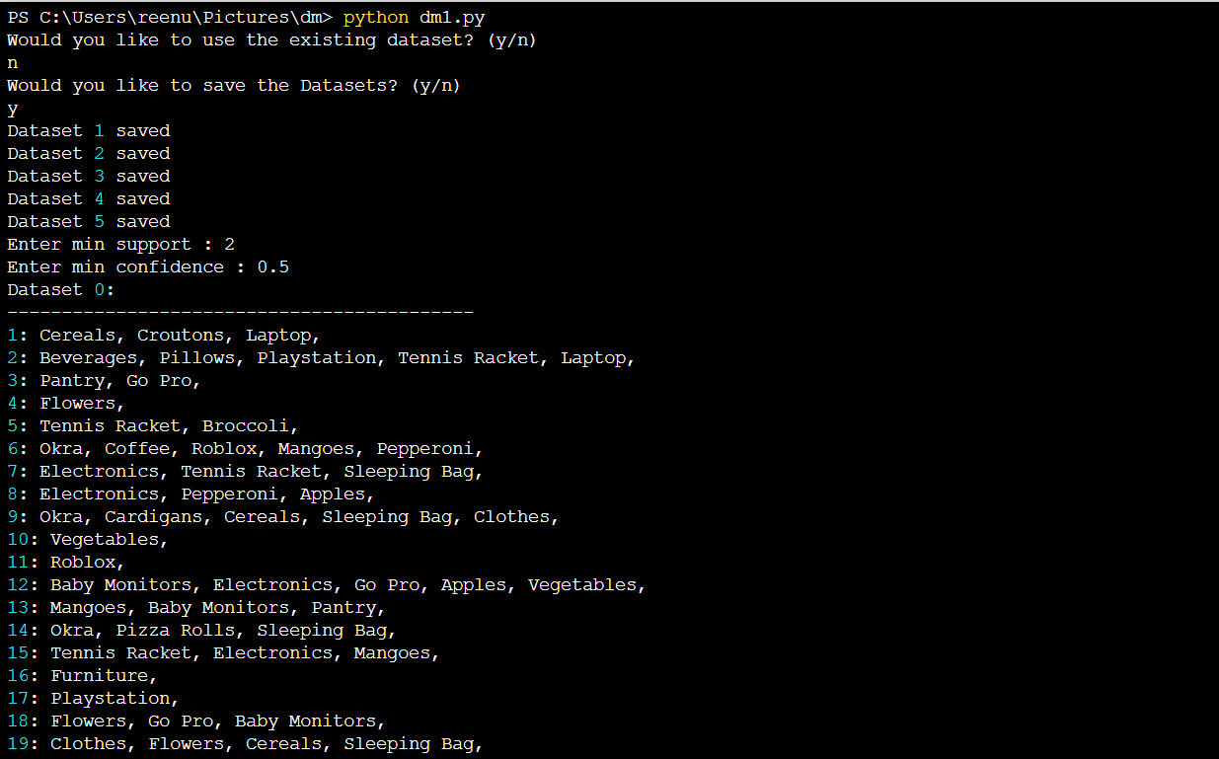
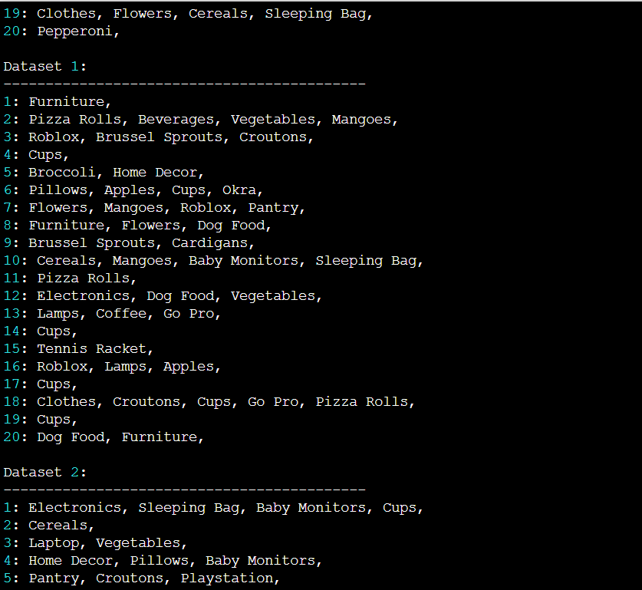
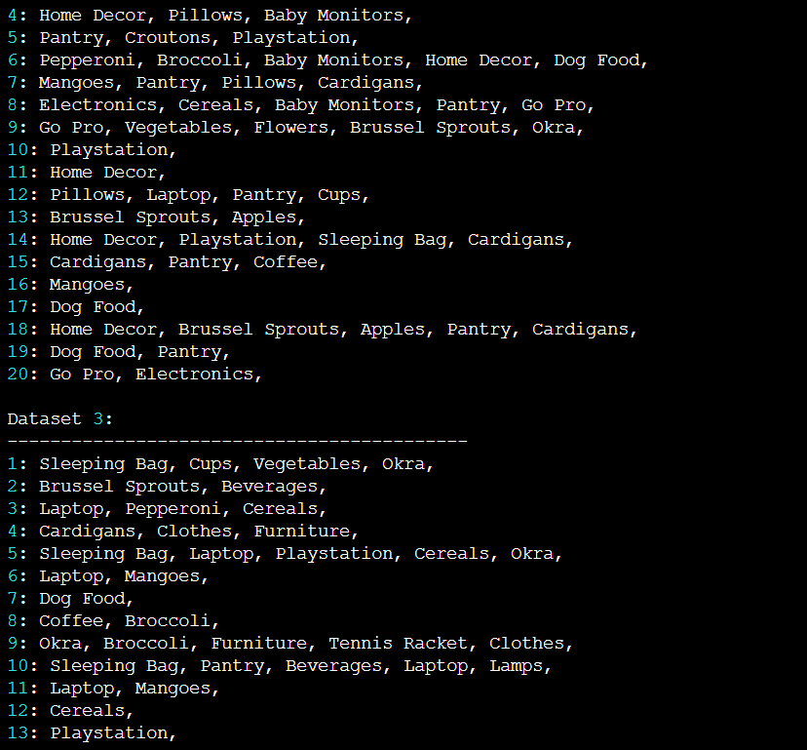
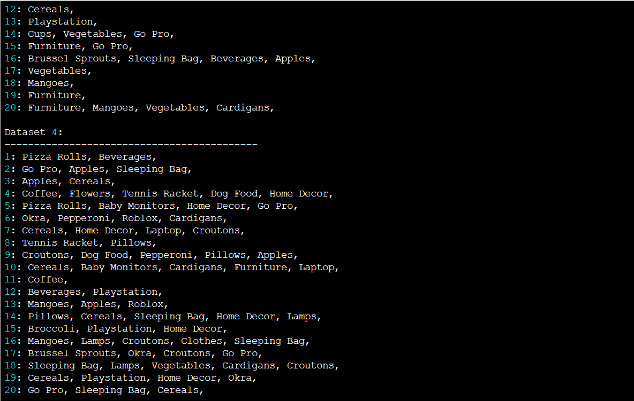
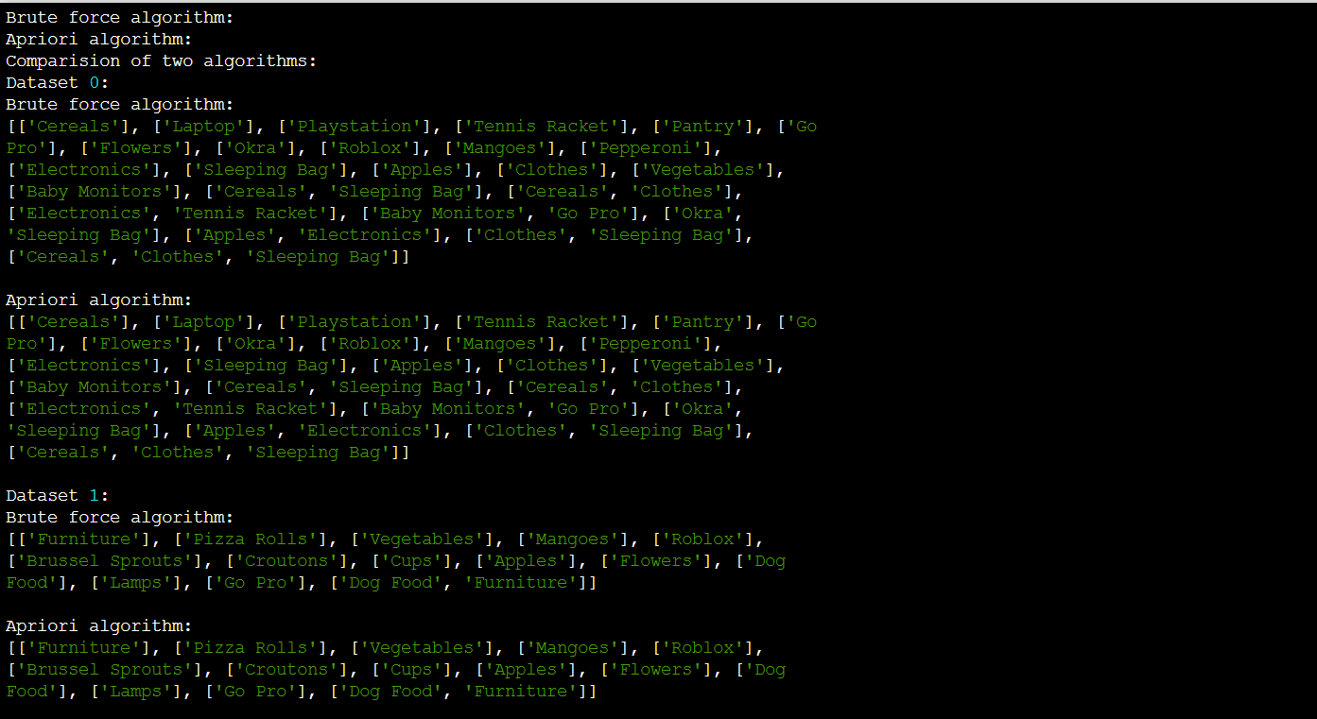
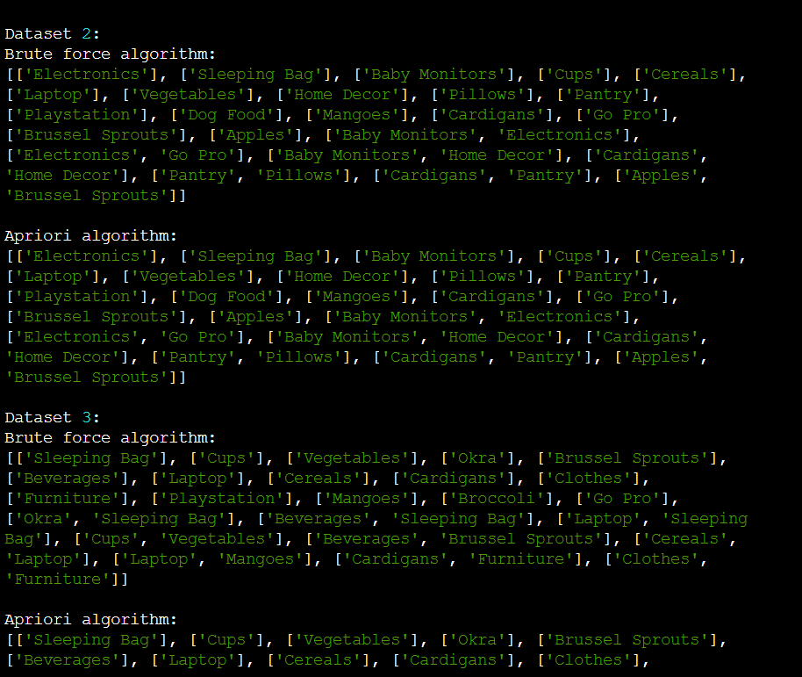
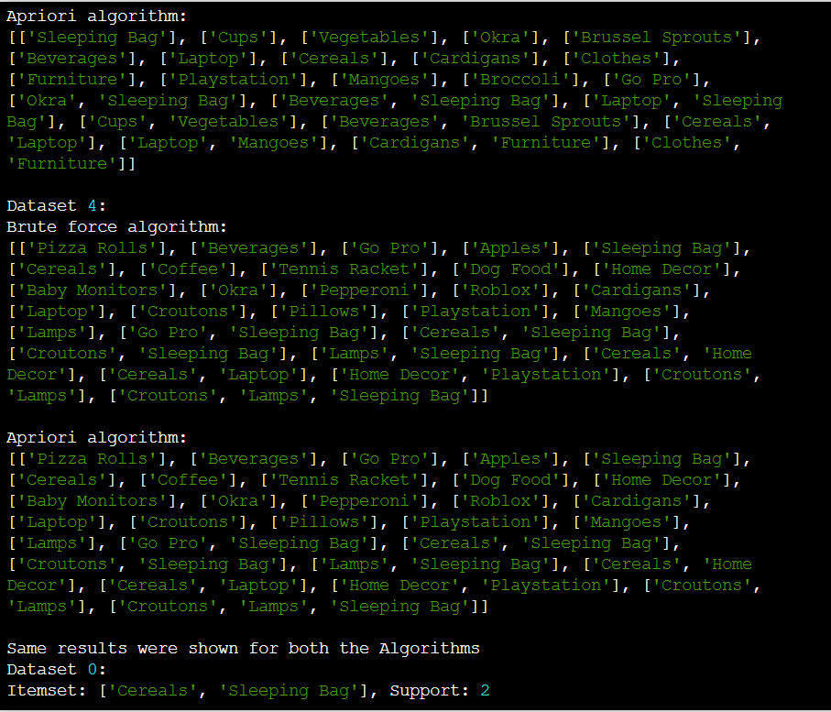
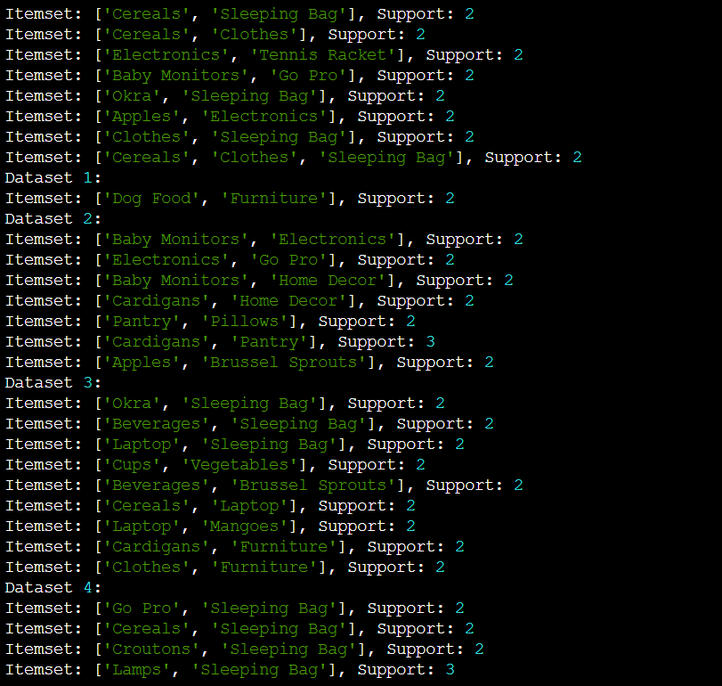
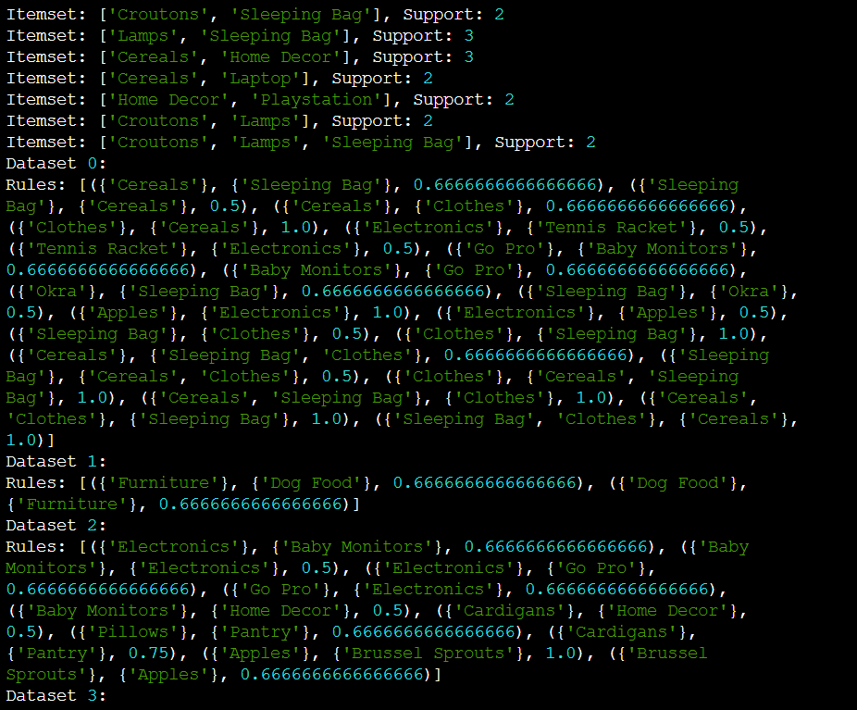

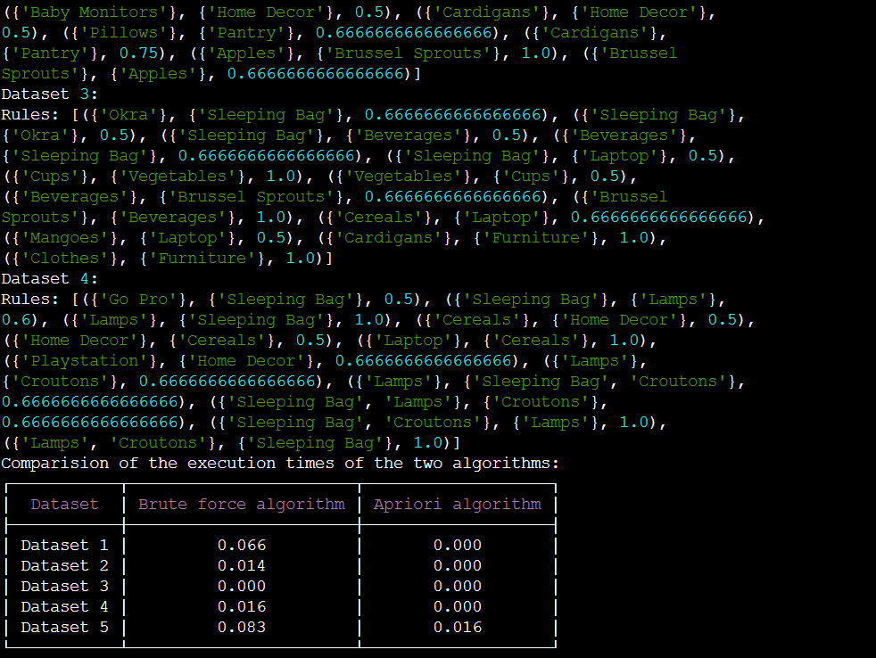
Conclusion: We can see in the above table that apriori is faster than brute force.

